# Day- 2 | SQL | SELECT DISTINCT

## The SQL SELECT DISTINCT Statement

The SELECT DISTINCT statement is used to return only distinct (different) values.

### Example:

Select all the different countries from the "Customers" table:

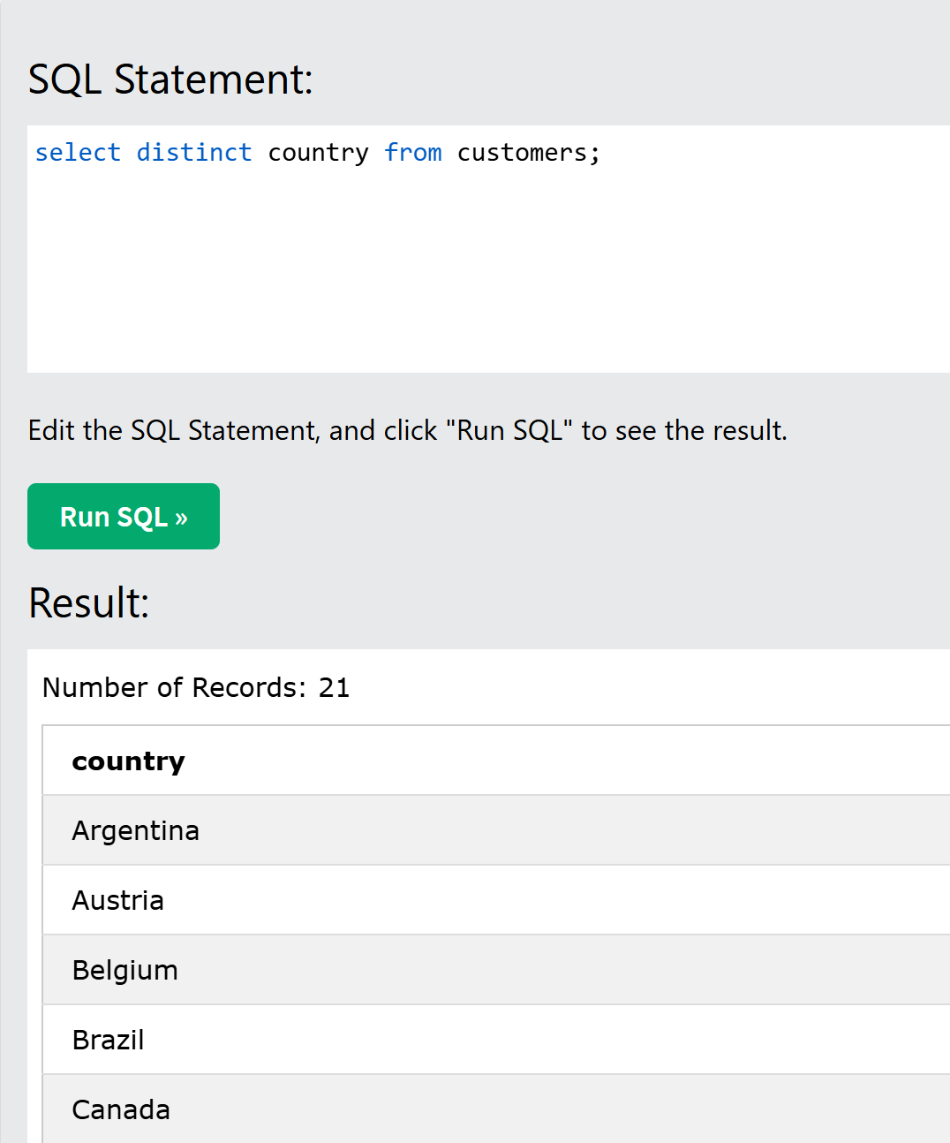

Inside a table, a column often contains many duplicate values; and sometimes you only want to list the different (distinct) values.

## Syntax: SELECT DISTINCT column1, column2, ... FROM table_name;

## SELECT Example Without DISTINCT

## If you omit the DISTINCT keyword, the SQL statement returns the "Country" value from all the records of the "Customers" table:

Below is example for your review:

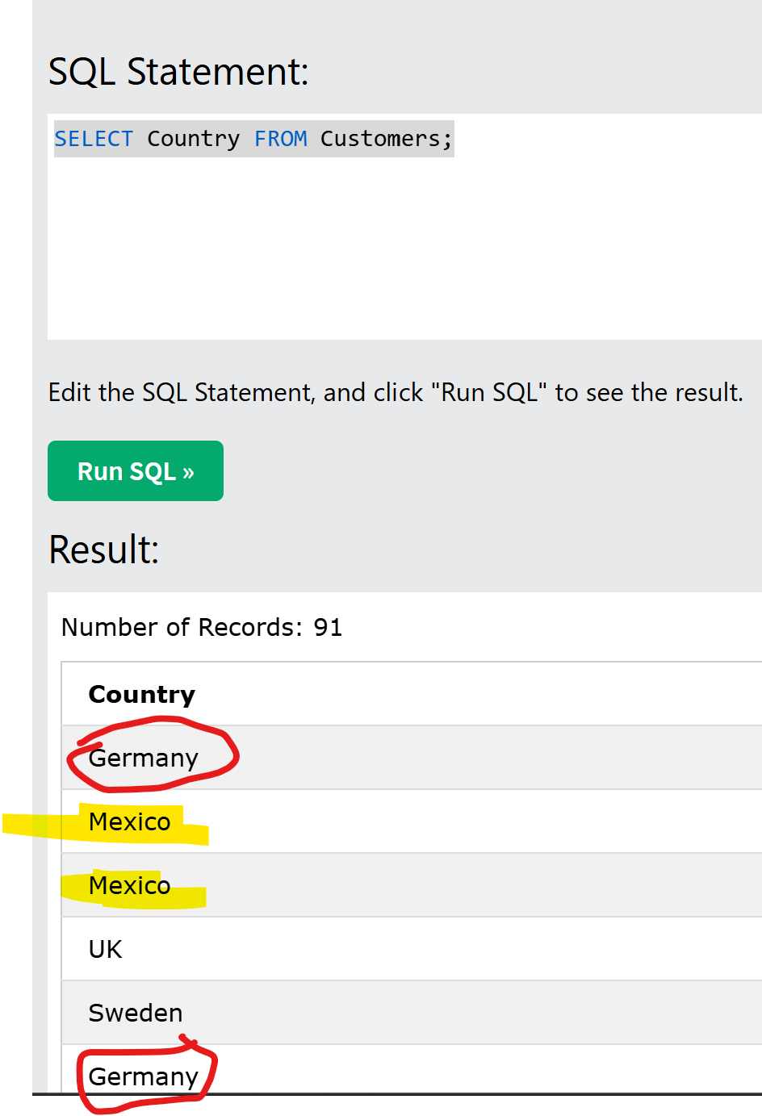

## Count Distinct:

By using the DISTINCT keyword in a function called COUNT, we can return the number of different countries.

SELECT COUNT(DISTINCT Country) FROM Customers;

**Note: The**COUNT(DISTINCT *column_name*) is not supported in Microsoft Access databases.

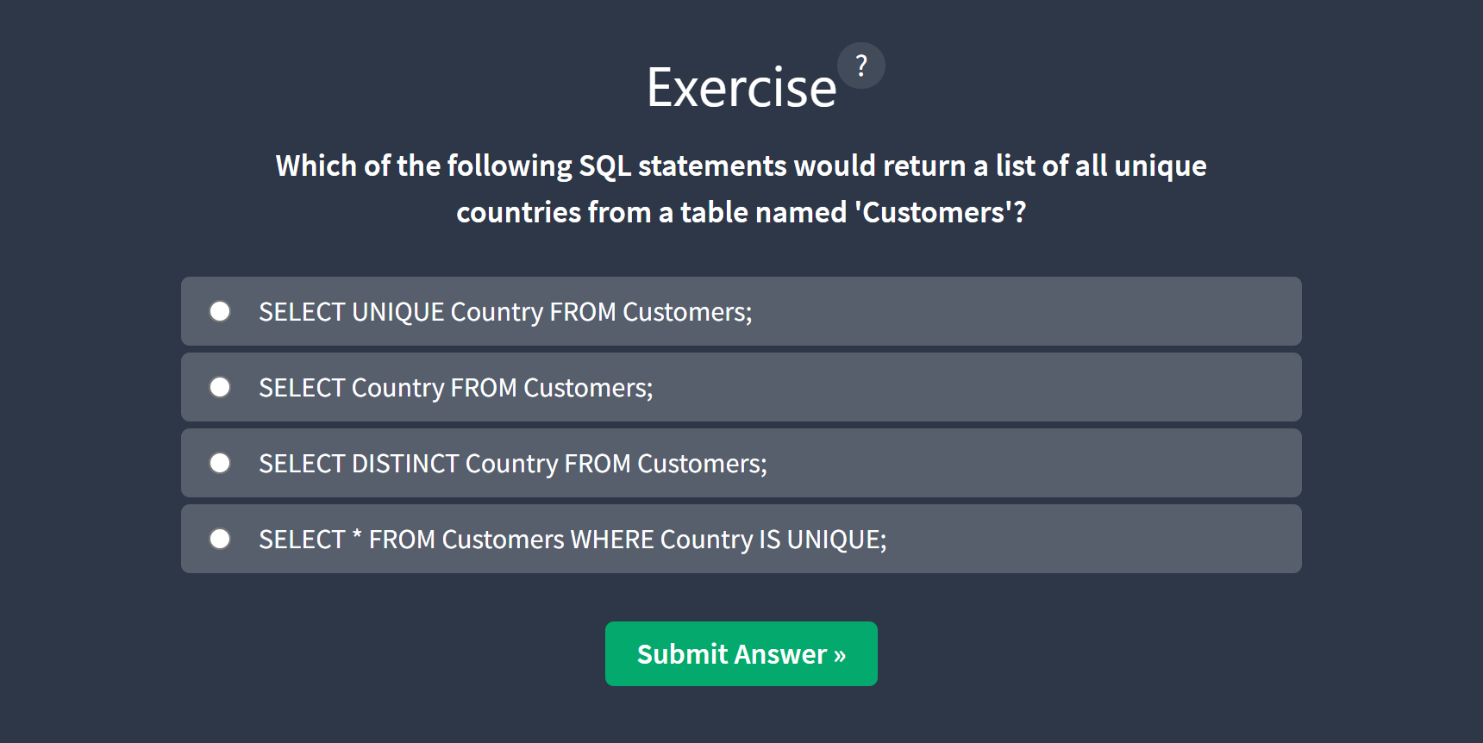

Answer: SELECT DISTINCT Country from Customers:

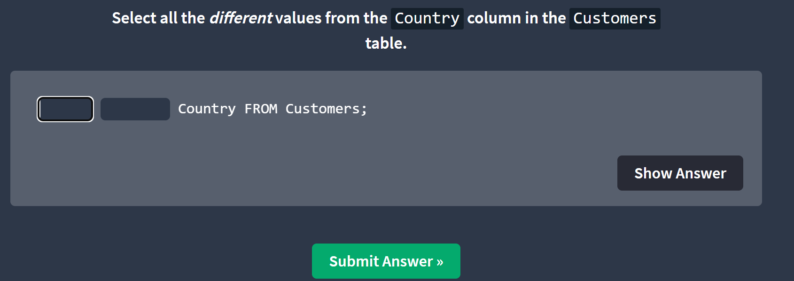

Answer: SELECT distinct country from customers;

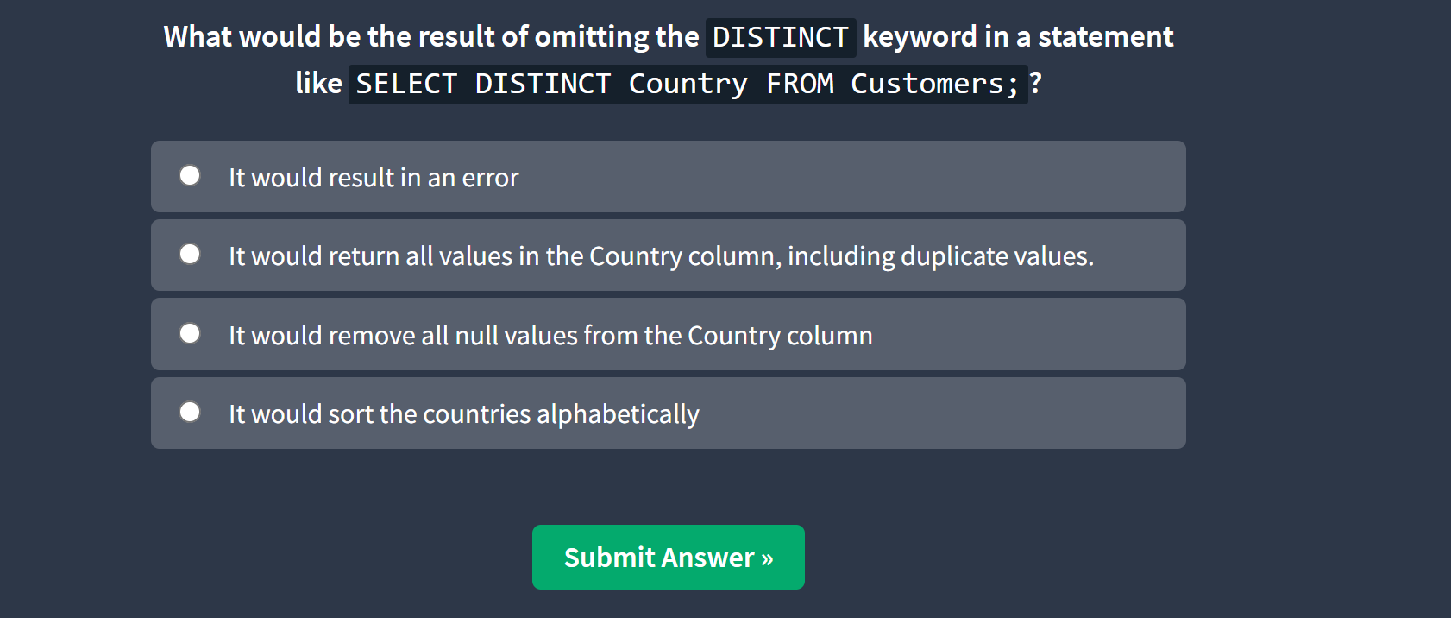

Answer: 2

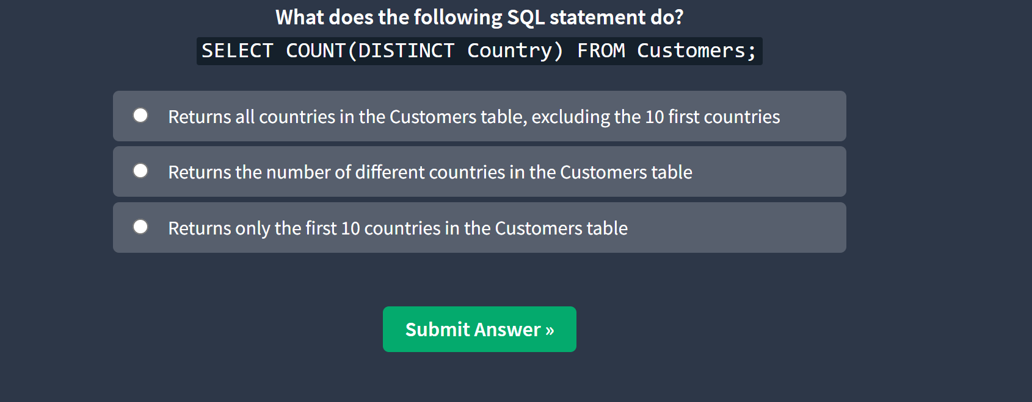

Answer: 2

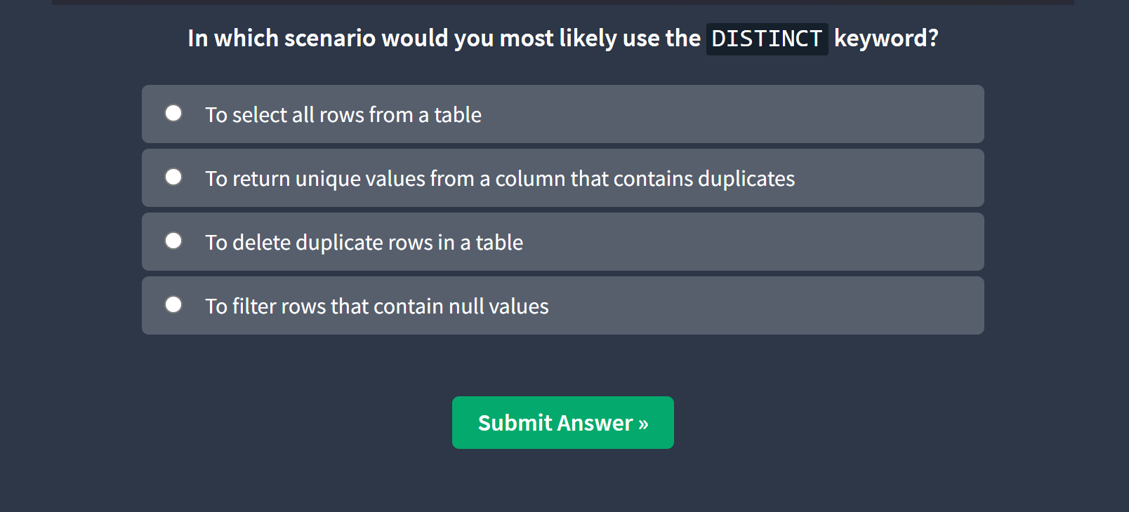

Answer: 2

